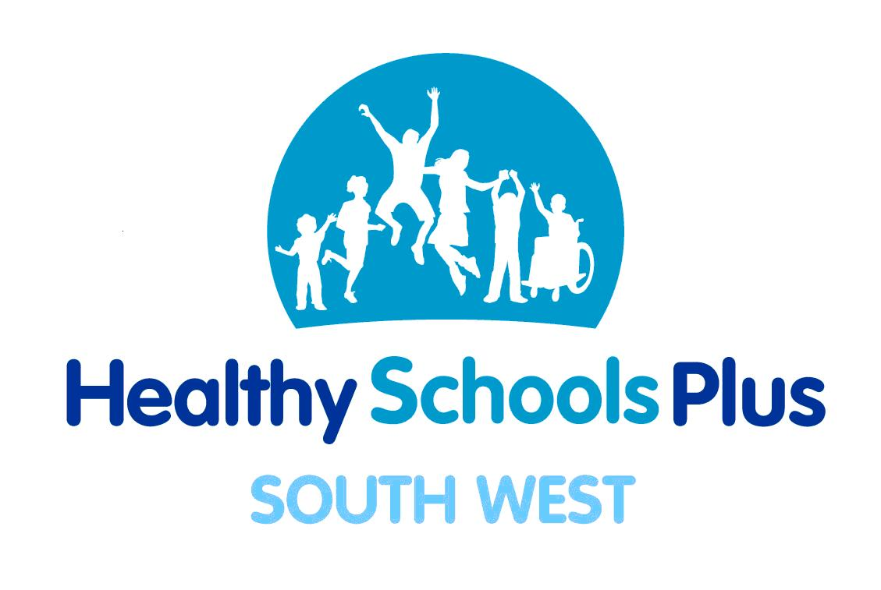

Healthy Schools Plus Action Planner
School: |  |  | NOR:
Local/School/CinCC Priority:
If CinCC, please state group chosen and the number of children
Healthier  Behaviour Outcomes: | 1) |  | Target number of children to achieve
Healthier  Behaviour Outcomes: | 2) |  | Target number of children to achieve
Baseline Data Collection
Outcome i) | Number of children baseline collected from: | Result: |  | Date collected:
Outcome ii) | Number of children baseline collected from: | Result: |  | Date collected:
Activities

Needs analysis:

Planning and preparation:

Implementation:

Ensure that we:
- Set up/use cluster school council network to audit pupil perceptions and to consult with pupils about the activities planned for Healthy Schools Plus
- Embed HS+ outcomes in the SEF and school development plan

PDE Team Support Required: | Eg: training, school visits, audits etc
Early Success Indicators: | Process: (list steps/activities to be taken with dates)  Outcome i)
Early Success Indicators: | Outcome ii)
Early Success Indicators: | Impact: (list interim target numbers to be achieved for each outcome with dates)  Outcome i)
Early Success Indicators: | Outcome ii)

